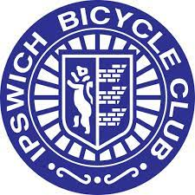
IPSWICH BICYCLE CLUB
https://ipswichbicycleclub.co.uk/

Open 10 mile Time Trial

Crowfield Circuit (CTT Course No. B10/32)

Promoted for and on behalf of Cycling Time Trials under their Rules and regulations on:

Saturday 28th May 2022 (14:00)

Officials:

Time Keeping:
Mr Angus Jardine Mr Mark Salter

Marshals: Tracy McKenzie, Chris Thornelow, Jerry Everett, J Carlyon
Refreshments: Claire Carlyon

Event Secretary:

Jon Carlyon
123 Parliament Road
IPSWICH
IP45EP
Email: carljonath@aol.com
Mobile: 01910 802047

Thank you to all the riders and helpers who contributed to the events success. I am a new TT secretary so lots to learn and do. Any advice or feedback gratefully received. A vet told me this is the first open run on this course for 21 years. It’s obviously a proper sporting course with lots of sharp climbs, I am considering a faster less technical sporting course for 2023 but would value rider’s opinions. Congratulations to the prize winners
Prizes
Scratch
1st £20: Lloyd Chapman Loose Cannon’s Conditioning
2nd £15: James Potter Loose Cannon’s Conditioning
3rd £10: Ian Short Team Salesengine.co.uk

Fastest Lady
£20: Ann Shuttleworth Cambridge CC

Vet on standard
1st £20 Keith Dorling Team Bottrill
2nd £15 Glenn Taylor Shorter Rochford RT
3rd £10 Peter Hurry Plomesgate CC

